**PROJECT SPECIFICATION**

**Refactor Udagram App into Microservices and Deploy**

# **Containers and Microservices**

| CRITERIA | MEETS SPECIFICATIONS |
| --- | --- |
| Divide an application into microservices | /feed and /user backends are separated into independent projects.  Github repo shows the monolithic app divided into 2 microservices:  Feed and user |
| Build and run a container image using Docker | Project includes Dockerfiles to successfully create Docker images for /feed, /user backends, project frontend, and reverse proxy. |
|  | |

Screenshot of DockerHub shows the images.

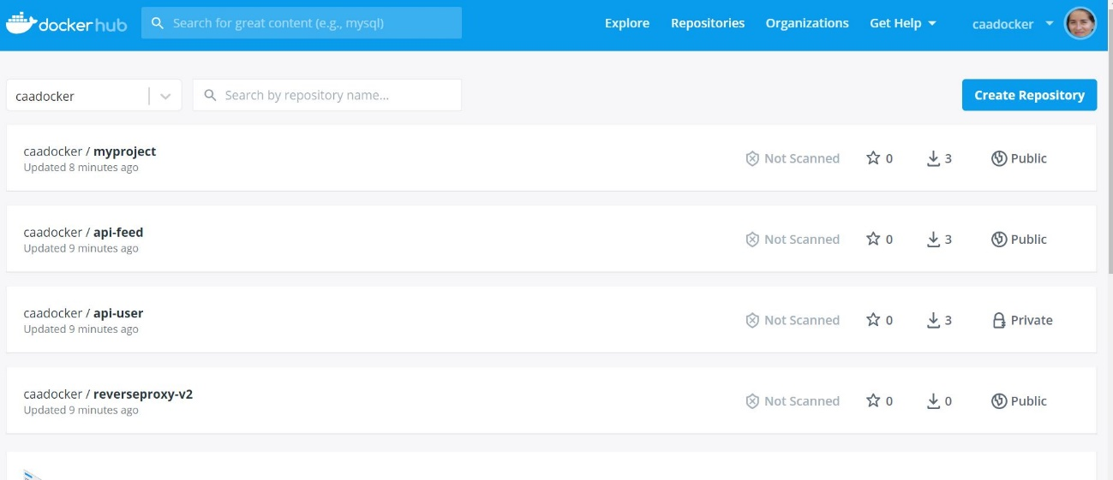

# **Independent Releases and Deployments**

| CRITERIA | | MEETS SPECIFICATIONS | |
| --- | --- | --- | --- |
| Use Travis to build a CI/CD pipeline | Project includes a .travis.yml file.  Screenshot of the Travis CI interface shows a successful build  and deploy job. | | |
|  | | |
|  | | |

# **Service Orchestration with Kubernetes**

| CRITERIA | MEETS SPECIFICATIONS |
| --- | --- |
| Deploy microservices using a Kubernetes cluster on AWS | A screenshots of kubectl commands show the Frontend and API projects deployed in Kubernetes.    The output of kubectl get pods indicates that the pods are running successfully with the STATUS value Running.    The output of kubectl describe services does not expose any sensitive strings such as database passwords. |
| Use a reverse proxy to direct requests | Screenshot of Kubernetes services shows a reverse proxy  to the appropriate backend | |
|  |  |
| Configure scaling and self-healing for each service | Kubernetes services are replicated. At least one of the Kubernetes services has  replicas: defined with a value greater than 1 in itsdeployment.yml file.  Screenshot of Kubernetes cluster of command kubectl describe hpa  has autoscaling configured with CPU metrics.  I had issues with one of the pods, was initially at CrashLoopBackOff, and I read some  mentors to suggesting to downsize replicas to one and increase nodegroup to  t2.medium or small | |

# **Debugging, Monitoring, and Logging**

| CRITERIA | MEETS SPECIFICATIONS |
| --- | --- |
| Use logs to capture metrics for debugging a microservices deployment | Screenshot of one of the backend API pod logs indicates user activity that is  logged when an API call is made. |
|  | |